M51Hv AHD 4CH HDD MDVR
User
Manual

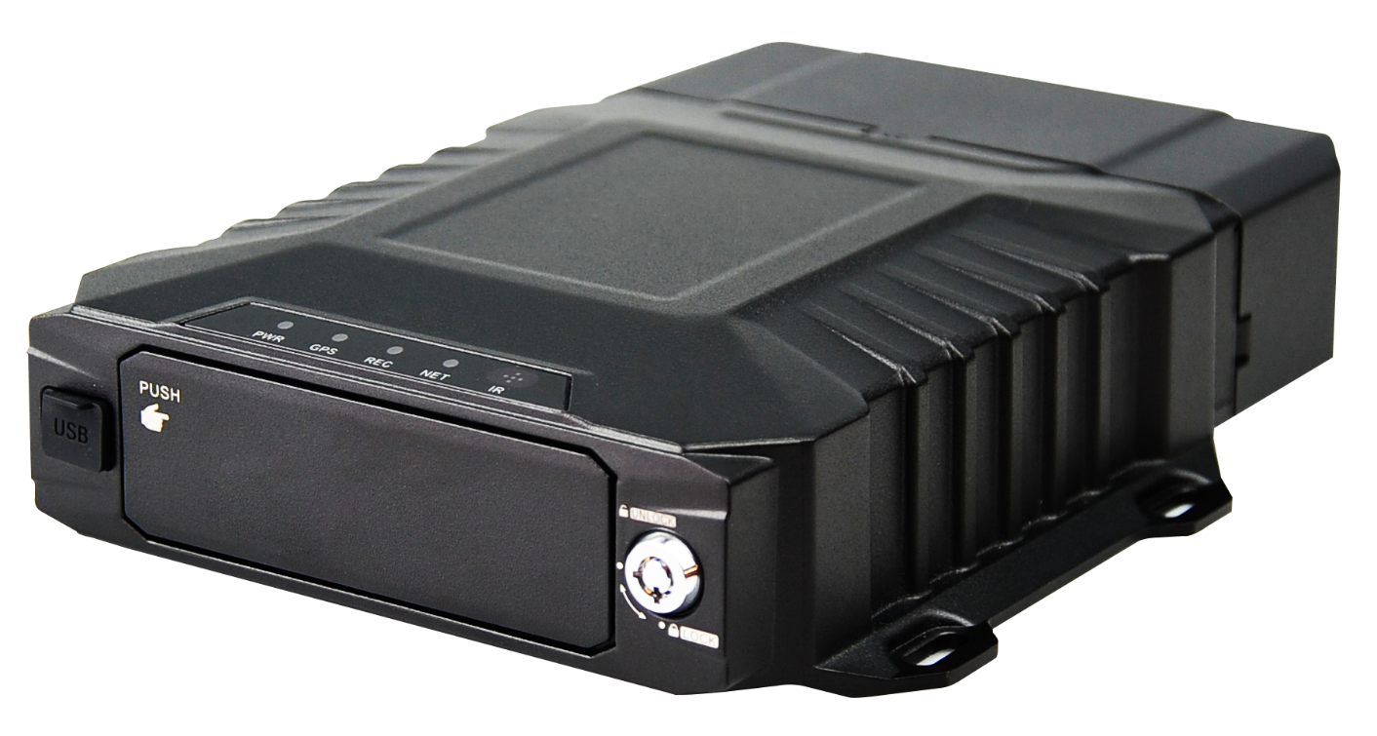

Contents

1. Important security rules and prompt 3
2. Product introduction 3
2.1 Overview 3
3. Product features 4
4. Product functions 4
5. Product specifications 5
6. Typical Applications 7
7. Product appearance interface description 8
8. Installation Precautions 12
8.1 Location 12
8.2 Power 12
8.3 Humidity 13
8.4 Temperature 13
8.5 Accessories 13
8.6 Injury 13
8.7 Maintenance 13
9. Power cable connection 14
10. Hard disk insertion and removal 14
11.Accessories description 16
12.Remote Controller 18
13.MDVR setup 19
13.1 Login 19
13.2 Main Menu 19
13.3 Playback 20
13.4 Preview 21
13.5 Settings 22
14. FAQ 37
14.1 Questions on device turn on 37
14.2 Questions on 3/4G 37
14.3 Questions on Wireless Module 38
14.4 Questions on Recording 38
14.5 Questions on Alarm 39
14.6 Others 39

Important security rules and prompt

Please read warnings before setting up and using this product:

- Should not be put on where rained or other corrosive liquid pureed for long time.
B) Keep far from heat source, strong magnetic field and dust.
C) Do not put heavy things on top of the equipment, no stacking debris around inside 50cm.
D) Do not flush water directly to the equipment while cleaning the vehicle.
E) Output power of the equipment not allow to connect to other not recommended equipment.
F) Do not try to put your fingers or anything into the cracks of the equipment while is working.
G) Do not open or disassemble the equipment without professional guide.
H) Do not change any modules while equipment is charged.

Product introduction

2.1 Overview
M51Hv is a cost-effective and high extendibility mobile digital video recorder (MDVR), developed especially for vehicle monitoring and remote video surveillance. It adopts high speed processor and embedded Linux system, combined with the most advanced technology of H.265 coding/decoding, 4G network, GPS/BD and WIFI. It supports 1080p,720p,D1 resolution video recording, vehicle driving record and video remote uploading. With the central software can do central remote monitoring based on alarm linkage, vehicle intelligent dispatch management and playback analysis based on central database. This device is competitive in anti-vibration, more rich function, high reliability, concise appearance and simple to deploy.

Product features

- Adopt high performance CPU, core ARM Cortex A7 dual core @max.1.3GHz, making the system run faster and more stable.
- Vehicle-specific interface with good user experience.
- The recording resolution is up to 1080P, using the latest H.265 digital encoding technology, high coding efficiency and flexible strategy.
- Supports the AP direct connection function, which can be directly connected to the device through the mobile phone APP to perform parameter setting and other functions on the phone.
- Supports a 2.5-inch HDD/SSD. The hard disk access mode is bare disk plug-in type. There is no need to add a hard disk box. The hard disk is removed from the pop-up mode. The whole operation is simple and easy to use.
- The hardware design has a power-off protection function. When the device suddenly powers off, the built-in super capacitor can be enabled to achieve normal shutdown, effectively avoiding the loss of key data.
- Built-in G-sensor accelerometer, adaptive installation position, no need to manually set, support driver driving behavior detection.
- All-aluminum alloy case, fanless design, with good heat dissipation.

4. Product functions
- Turn on/off
a1 Support ACC ignition power on, regular power on, trigger boot, remote boot.
a2 Support ACC delay shutdown, timed shutdown, trigger shutdown, remote shutdown.

- Local monitoring function
b1 Support local output 1/2/4/5/8 screen live preview, trigger single channel screen preview by alarm.
b2 Support motion detection, video loss, video power short detection detection.
b3 Support local audio and video playback, support fast forward and rewind function.

- Local audio and video recording storage
c1 Support a 2.5" SATA hard drive and a SD card.
c2 The file format is compatible with Windows systems and uses hard disk space pre-segmentation.

- Data backup
d1 Support USB data export backup.
d2 Support bare disk pull out data backup.
d3 Support remote platform data download backup.

- Extension
e1 Local support for RS485, support for a variety of peripheral sensor access.
e2 Local support for RS232, support for a variety of peripheral sensor access.
e3 Support for external serial port expansion boxes.

- Remote monitoring function
f1 Support 10M/100M adaptive network interface.
f2 Support 4G function.
f3 Support WIFI function, 2.4/5.8G optional.
f4 Support VMS, CMSV6 platform, provide SDK, and access more platforms.
f5 Supports protocols such as DHCP, DNS, NTP, and SADP.
f6 Support remote preview and video recording.
f7 Support remote video and audio playback.
f8 Support WIFI automatic download.
f9 Support remote intercom between platform and device.
f10 Supports PTT calls between devices and devices.
f11 Support remote acquisition and configuration parameters, support remote export and import of device parameters.
f12 Support remote access to device operating status, system log and alarm status.
f13 Support remotely format hard disk, upgrade program, restart and other system maintenance operations.
f14 Support remote search, playback and download.
f15 Support RS-232 remote transmission.

5. Product specifications

Item |  | Description
Model |  | M51Hv
OS |  | Linux3.18
Operating |  | Cell phone APP, PC client, Remote controller
Functions Summary |  | Preview, recording, playback, network transmission, positioning, AI analysis, multiple sensor data acquisition.
Video and Preview | Video Input, Output,Signal standard | AHD input:8ch 1080p/15fps,8ch 720p/30fps,8ch D1/30fps,4ch 1080p/30fps. IPC input:1ch default, externally expandable 1-4ch Output: 1ch CVBS default, VGA optional(1024x768) Signal standard:1.0Vp-p, 75Ω, NTSC/PAL optional
 | OSD | Character superposition function, information superposition of time and date, device ID and GPS, alarm,etc.
 | Video Compression Format | Compression coding. Applying H264/H.265 hi-performance processor.
 | Image quality | Code stream, frame rate optional
 | Preview | 1/4/6/8/9 channel preview
 | Resolution | AHD: 1080P:30fps/1M/2M/4M/6M 720P: 30fps/1M/2M/4M/6M  D1:30fps/512K/1M/2M  IPC: 1080P: 30fps/1M/2M/4M/6M 720P: 30fps/1M/2M/4M/6M
Audio | Audio Input, Output | 4ch analog audio input, 1ch mic input; 2ch audio output. 2.0Vp-p, 4.7kΩ
 | Compression Format | G.711A, G.726
Recording | Storage Medium | Supporting one 2.5” SATA hard drive and one SD card
 | Video Strategies | Recording at start up by default, supporting timed recording, recording triggered by alarm and event, as well as manual recording
 | Alarm pre-recording | 0-60min
 | Alarm recording delay | 0-30min
 | Playback channel | Support local 1/4/6/8 channel playback
 | Browse mode | Time, channel, event.
Communication Ports |  | RS232, RS485
ADAS |  | Built-in (Optional)
Wireless Transmission |  | 4G wireless transmission module, EVDO/TD-SCDMA/WCDMA/TDD-LTE/FDD-LTE ect.  Wi-Fi module, 802.11b/g/n,2.4G/5.8G optional. Ethernet: Network aviation head(100M)
Position |  | GPS/BD: Positioning, speed detection, time synchronization
Power Supply and Power Consumption | Power Supply | 1ACC on/off
 | Input Voltage | DC:+8V ~ +36V
 | Output Voltage | +12V@1A; +5V@1A
 | Power Consumption | Max 25W consumption, about 0W in standby mode
Operating Environment | Temperature | preheating: -20℃ ~ +70℃
 | Humidity | 8% to 90%
Size |  | 176.9mm（L）*186.8mm（W）*54mm（H）
Weight |  | NW:1.4KG  GW:2KG

6. Typical Applications
Applications: bus, school bus/staff bus, logistic trucks, coach bus, taxies, train/metro/light rail.
Topological graph of main applications;

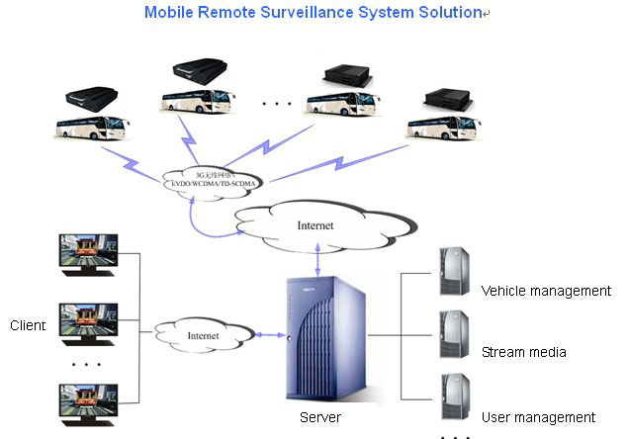

Product appearance interface description

- Product size:(mm)

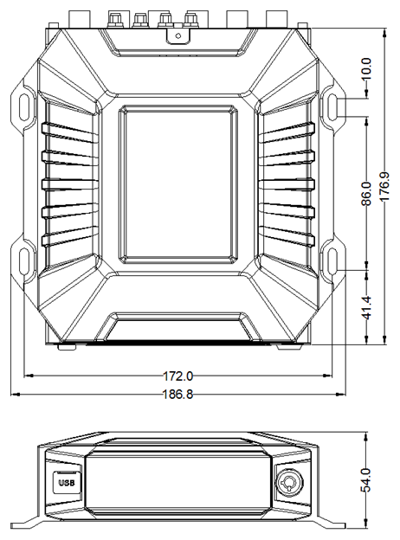
- Front panel schematic
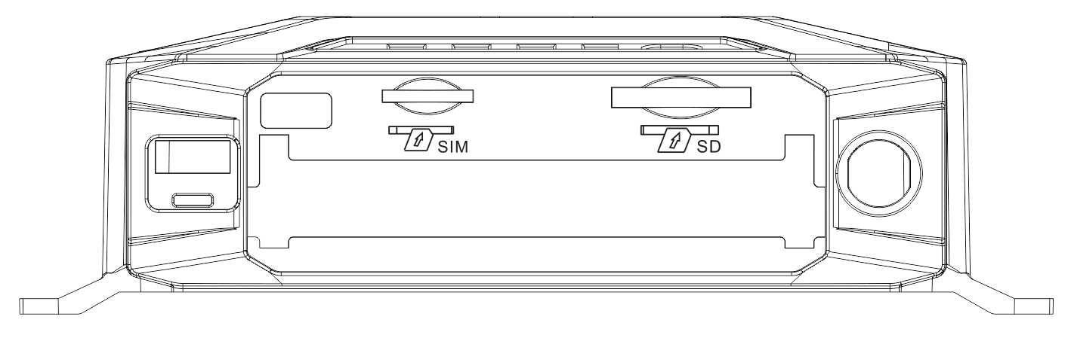

NO. | Name | Description
1 | SIM | 4G SIM card slot
2 | SD | SD card slot
3 | USB | USB 2.0
4 | Lock | Hard disk lock with electronic lock function
5 | PUSH | The position of the door is pressed, and when it is pressed, it automatically pops open.
6 | GPS | GPS indicator light: steady light means GPS successfully, flashing means not，long off the indicator light means that the module does not exist
7 | NET | Network light: The server is always on when the system is successfully registered, otherwise it blinks， long off the indicator light means that the module does not exist
8 | POW | Power input status indicator is always on
9 | REC | the indicator light is always on, it means no recording, flashing means it’s recording, and long off means the medium doesn’t exist.

- Rear Panel Definitions
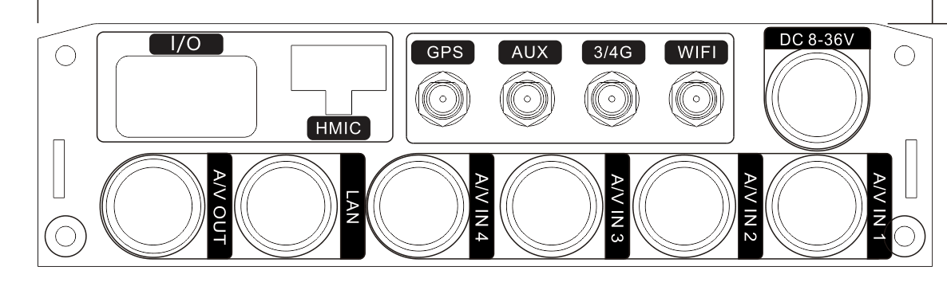
NO. | Icon | Description
1 | DC8-36V | Power input
2 | A/V IN1 | Audio and video input channel one
3 | A/V IN2 | Audio and video input channel two
4 | A/V IN3 | Audio and video input channel three
5 | A/V IN4 | Audio and video input channel four
6 | LAN | Wired network port(100M)
7 | A/V OUT | Audio and video output
8 | I/O | Alarm input/output
9 | HMIC | Intercom
10 | GPS | BD/GPS antenna interface
11 | AUX | Antenna expansion interface
12 | 3G/4G | 3G/4G antenna interface
13 | WIFI | WIFI antenna interface

Notice:
- Since some functions of the device are optional functions, the interface is subject to the actual product.
- The pin definition of each aviation plug is subject to the label on the corresponding connector.

- HMIC Cable

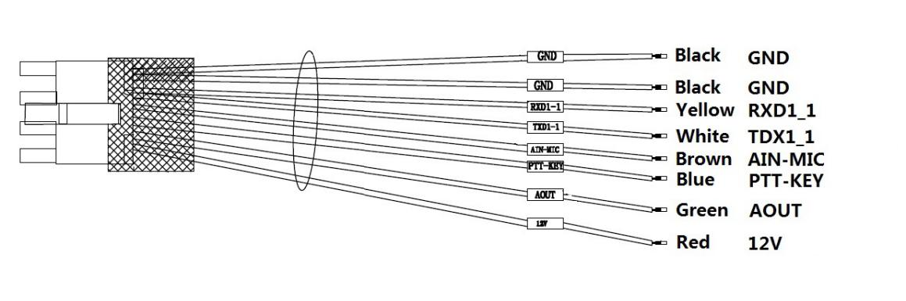

Cable color | Mark | Description
Black | GND | GND
Black | GND | GND
Brown | RXD1_1 | RS232 RX
Purple | TXD1_1 | RS232 TX
Blue | AIN-MIC | Audio input
Blue | PTT-KEY | PTT
Green | AOUT | Audio output
Red | VCC12V | 12V Power output

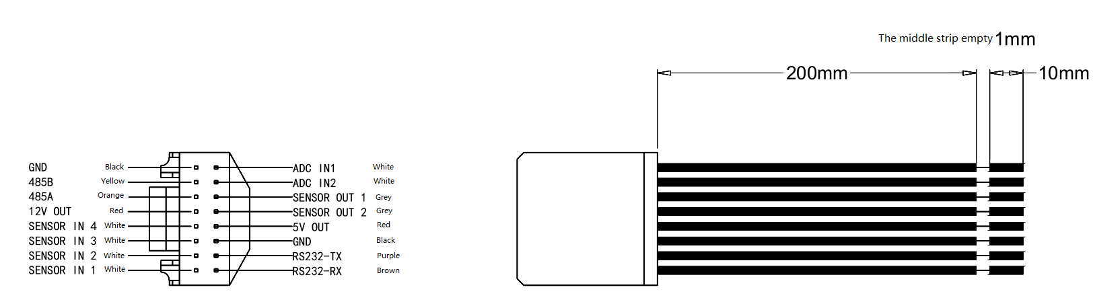

Cable color | Mark | Description
Black | GND | Ground wire
Yellow | 485B | RS485B
Orange | 485A | RS485A
Red | 12-OUT | 12V Power output
White | SENSOR-IN4 | Alarm input channel 4
White | SENSOR-IN3 | Alarm input channel 3
White | SENSOR-IN2 | Alarm input channel 2
White | SENSOR-IN1 | Alarm input channel 1
White | ADC IN1 | Analog input channel 1
White | ADC IN2 | Analog input channel 2
Gray | SENSOR OUT1 | Alarm linkage output 1
Gray | SENSOR OUT1 | Alarm linkage output 2
Red | 5V OUT | 5V Power output
Black | GND | Ground wire
Purple | RS232-TX | RS232 TX
Brown | RS232-RX | RS232 RX

Installation Precautions
To ensure the Mobile Digital Video Recorder (MDVR) to run smoothly within the product warranty, please adhere to all requirements and follow the instructions listed below to install:

8.1 Location
- Install MDVR in a dry and ventilate location shielded from direct contact with excessive humidity and moisture, rain and other sources of liquid. Do not install MDVR on a recessed surface where liquids may accumulate or on spots where liquids may drip down.
- MDVR should be located at spots that are free of electromagnetic interference
- Keep MDVR away from direct sunlight and/or other sources of heat during installation.
- Do not install the unit on a surface that is vulnerable to excessive vibration.

8.2 Power
- MDVR supports power supply ranges from 8v ~36v DC. Handle all electrical equipments with cautions to avoid injuries.
- Turn off the power before connecting/disconnecting MDVR from the power supply.
- MDVR is connected to both the vehicle ignition and the battery. MDVR is power supplied by the battery when the vehicle starts up, and MDVR can drain any battery if the ignition is not turned off.
- Correctly attach the MDVR ground cable to the vehicle to complete the power circuit.
- Disconnect MDVR from the power supply when it is not in use for an extended period of time.

8.3 Humidity
- The working humidity for MDVR is between 10-95%.
- Do not handle MDVR with wet hands, while standing in water, or while in contact with other sources of liquid, as these can potentially result in an electric shock.

8.4 Temperature
- MDVR with SD card operates in a sealed enclosure with no airflow; its minimum and maximum operating temperatures are -25°C (-13°F) and 60°C (140°F) respectively.

8.5 Accessories
- MDVR, cameras, wires and other accessories need to be placed at secure spots so that they won’t be misused and/or destroyed by passengers and/or driver. Also, do not install the equipments at places that would restrict normal functioning of the vehicle.
- Do not attach any device to MDVR.

8.6 Injury
- MDVR, cameras, wires and other accessories need to be properly installed to prevent damages; and all transportation regulations should be followed to avoid passenger injury.

8.7 Maintenance
- To clean surface(s) of MDVR, only use cleansers that are approved for electrical equipments. Do not use unspecified chemicals or household cleansers.

Power cable connection
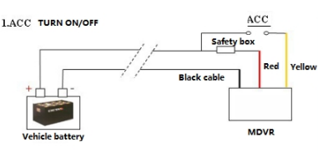

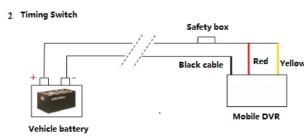

Hard disk insertion and removal

Hard disk insertion：
Notice: The hard disk insertion mode of this device is bare disk, no hard disk box is needed.

  - Open the device hard disk lock, press the door to make the door automatically pop up, and pull out the hard disk box handle.

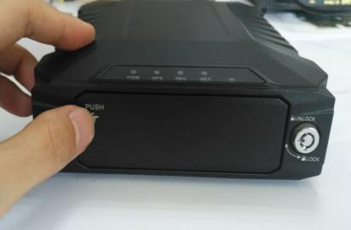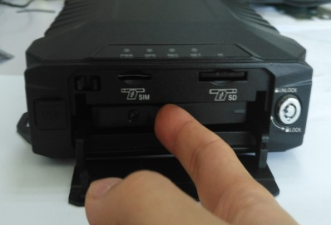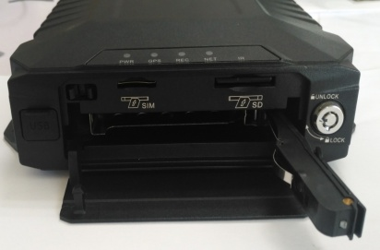

  - Insert the hard disk 70% length, please pay attention to the hard disk insertion direction.

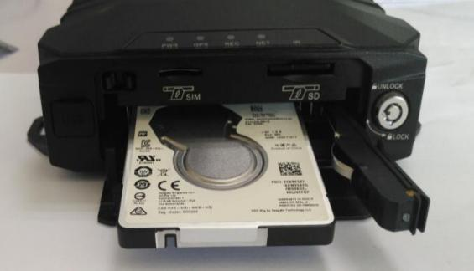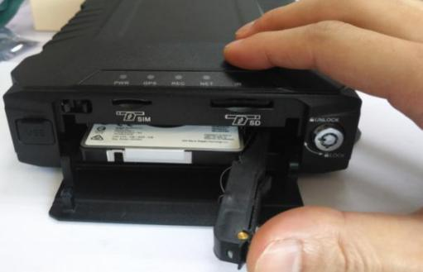

  - Push the hard disk box handle to make the hard disk completely enter the device, and hear the humming sound, and detect the handle is locked.

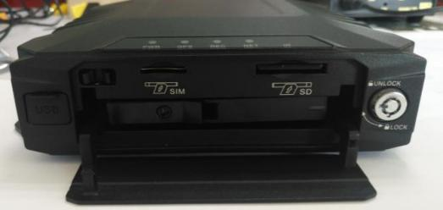

  - Close the door and close the hard disk lock.

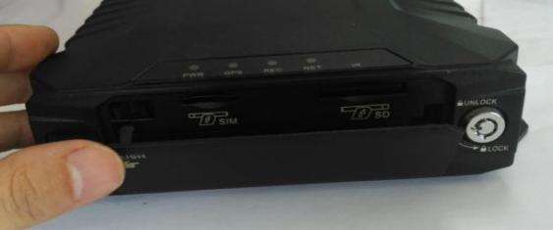

Hard disk removal:

  - Open the device hard disk lock, press the door to make the door automatically pop up.

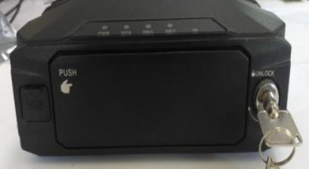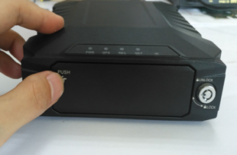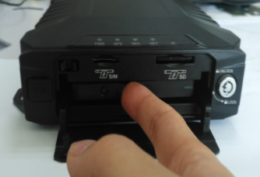

10.6Pull the hard disk box handle to make the hard disk box pop up automatically.

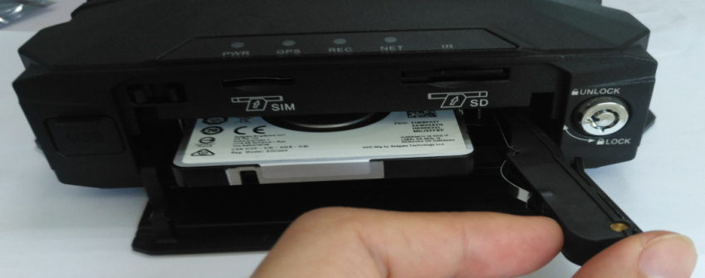

10.7 Remove the hard drive .

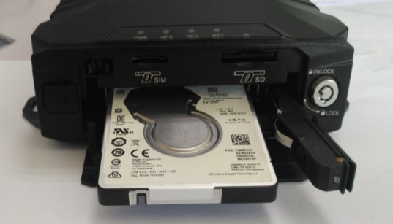

11.Accessories description

Standard：

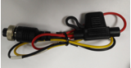 | 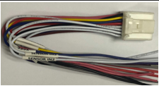 | 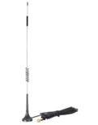
Power cable | IO cable | 4G antenna(if you buy 4g type)
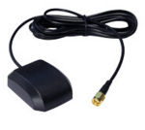 | 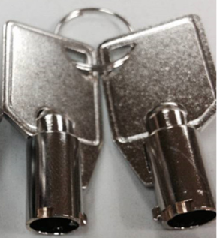
GPS antenna(if you buy gps type) | Keys
Optional:

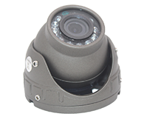 | 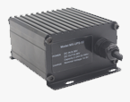 | 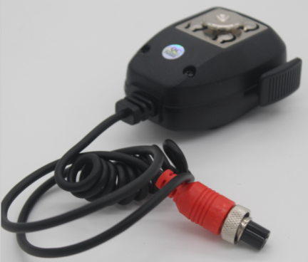
Camera | UPS | Hand held microphone
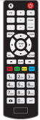 | 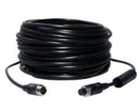
Remote controller | Extension cable

12.Remote Controller
Key | Function | Image
[0-9] | [0-9] keys: In the setting status, the numeric keys are used for number selection. During playback, keys 1, 2, 3 and 4 are used for switching between single window of channels 1-4, key 0 is used for switching to synchronous playback of 4 channels.
[DEL] | Backspace when inputting numbers.
[RETURN] | Exits to the preview menu or returns to the parent menu.
[ENTER] | Confirms parameter selection and settings as well as operations like play.
▲, , , | Arrow keys that move the cursor upward, downward, leftward and rightward.  The left and right keys are used for increasing and decreasing the volume during surveillance playback.  - Fastback, 2x/4x/8x/16x for selection, press once to switch to the next speed in order, press [Play] to resume normal speed;  - Fast-forward, 2x/4x/8x/16x for selection, press once to switch to the next speed in order, press [Play] to resume normal speed;
 | Perform 4-screen picture capture function
 | Input dot character, such as ip “192.168.1.1”
 | Control external pan/tilt
+ | Can enter the test interface, view module information, etc., easy to debug.
Others | Function retention button.

13.MDVR setup

13.1 Login

- When password is set DISABLE, Press【ENTER】key on the remote controller into the main menu directly.
- When password is set ENABLE, Press 【ENTER】key on the remote controller into the login menu as below, enter the correct user name and password, then press【ENTER】key into the main menu.
- Default user name: admin. Administrator default password is “999999”, Normal User default password is “888888”.
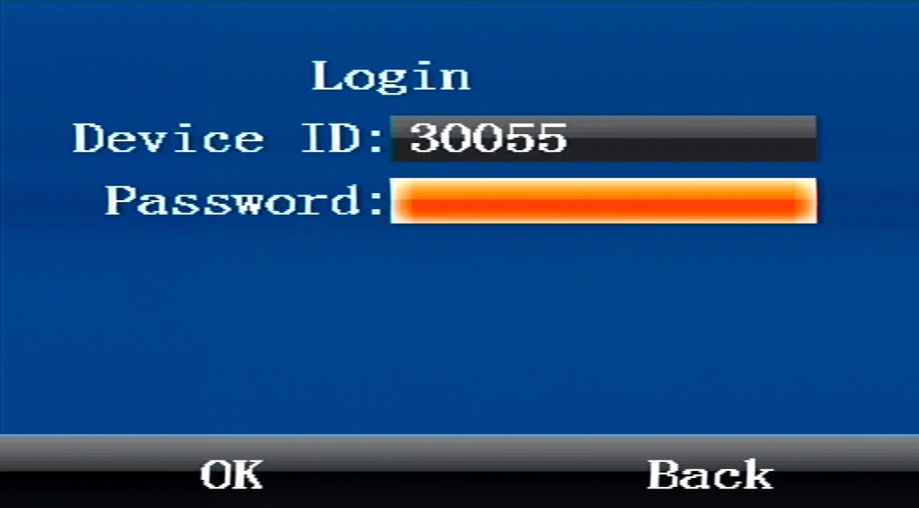

13.2 Main Menu
After login successfully, enter the main menu as below. It includes 4 items: Playback, Preview, Settings, Tools.

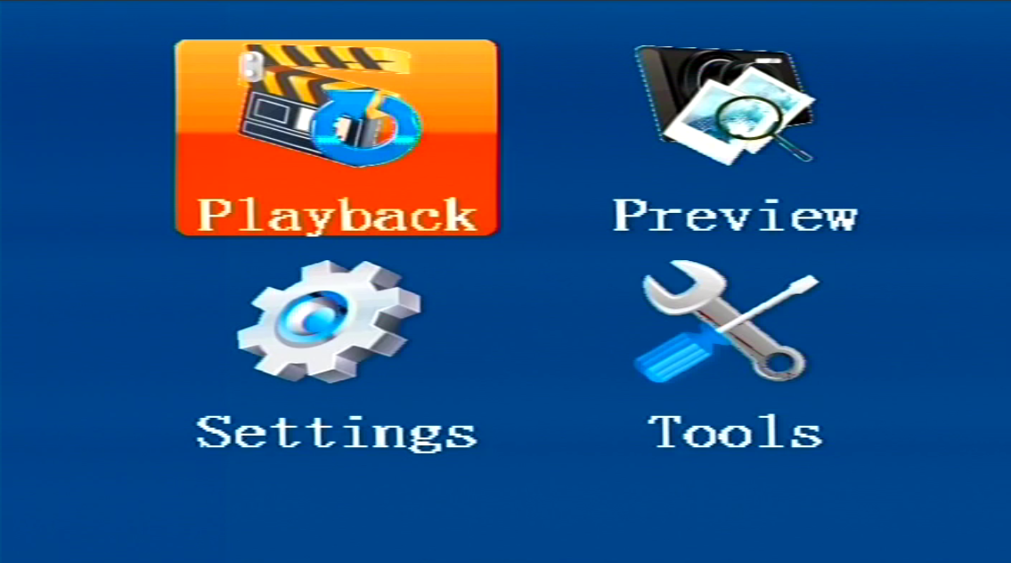

13.3 Playback
You can search all video files including normal files, alarm files by record time, file type when you enter Playback menu. Here’s the detailed description:

- Rec Type：The type of video file includes alarm file and all file. Press 【ENTER】key to select the type of video file which need to search. System default selection is all file.
- Date: Press the digit keys to setup the date，System default selection is current day.
- Start： Press the digit keys to setup the time, default time is 00:00.
- End： Press the digit keys to setup the end time, default time is 23:59.
- OK: Select the "OK" button And press 【OK】 key to enter the following search results menu.
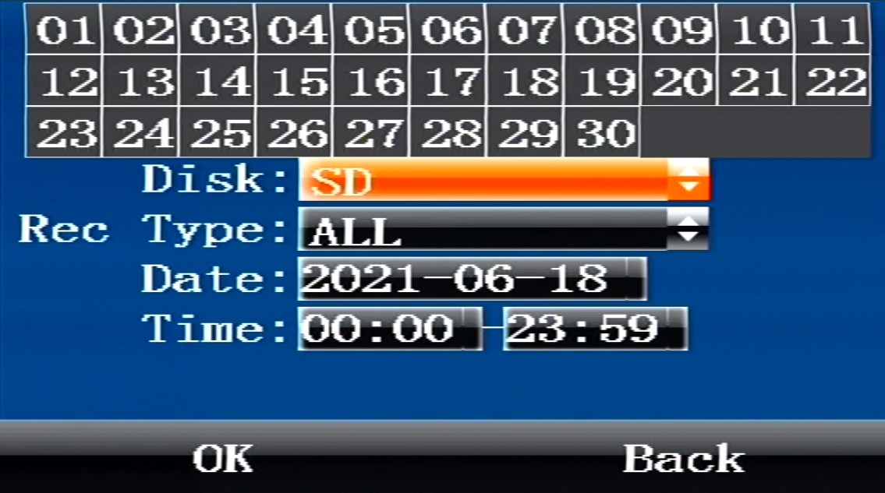
- Press the direction keys to view recording information, press 【ENTER】 to play selected file, press【RETURN】 to return back the upper menu;
- Press the direction keys to select "First", "Prev", "Next", "Last", and press 【ENTER】 to go to corresponding page.

13.4 Preview
You can search all snap picture files by time when you enter preview menu. Here’s the detailed description:
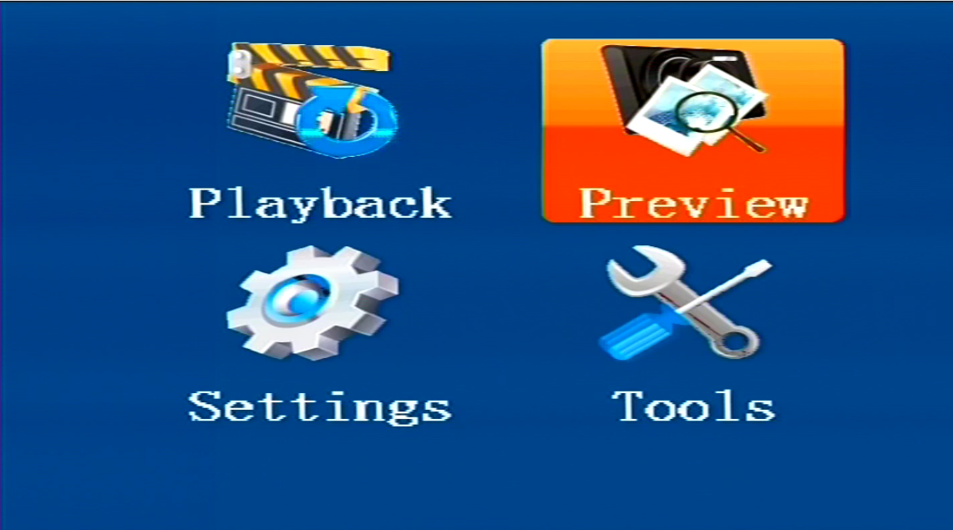
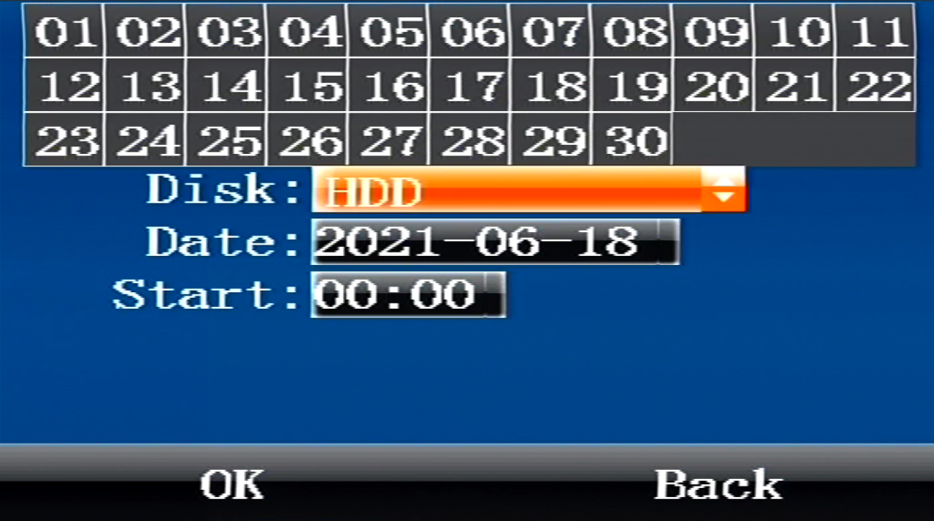

- Date: Press the digit keys to setup the date，System default selection is current day.
- Start： Press the digit keys to setup the time, default time is 00:00.
OK: Select the "OK" button And press 【OK】 key to enter the following search results menu.

13.5 Settings
Settings menu is used to set items about mdvr system config, such as encode,net etc. it is composed of 6 parts: Basic,Alarm,Net, Encode,Record,Serial.
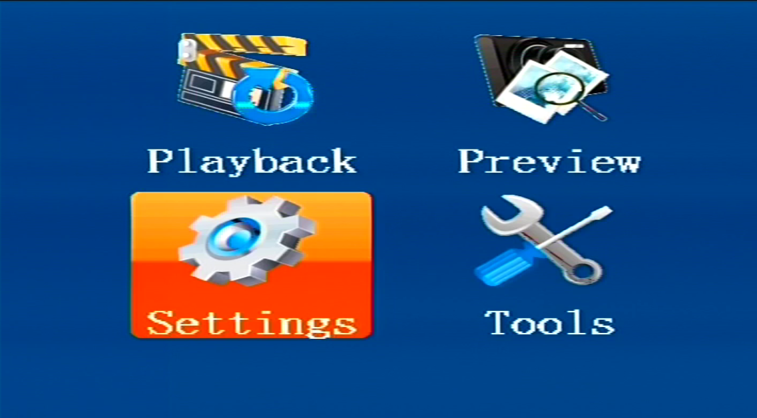

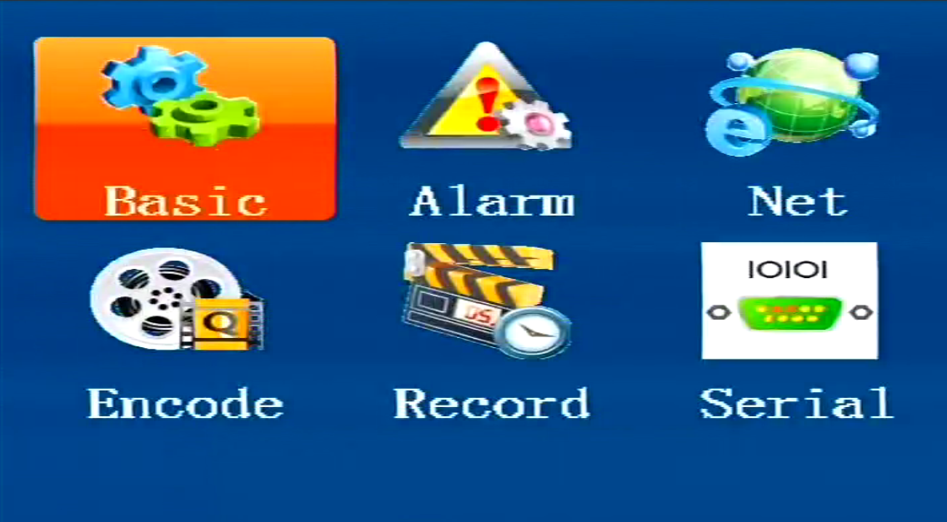

13.5.1 Basic
This menu is used to set mdvr time and user password, mdvr owner info,mirror and power.

- Time
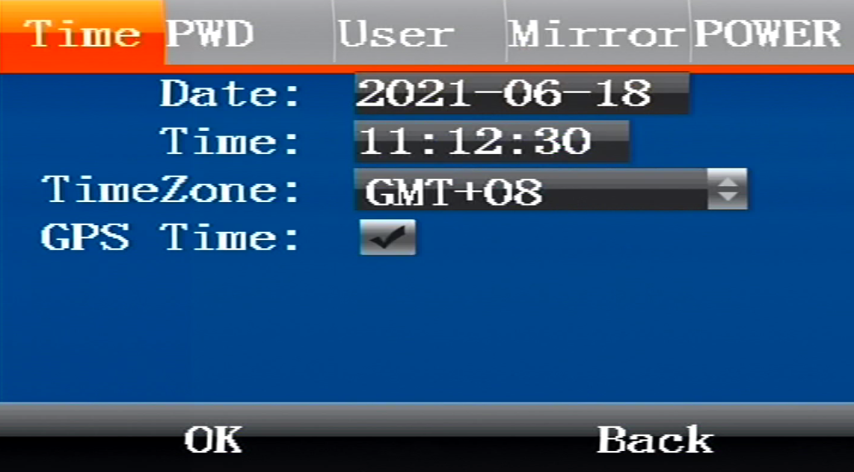

- Date：Press the digit keys to setup the date.
- Time： Press the digit keys to setup the clock.
- Time Zone： Press the enter keys to select timezone.
- GPS Time: Check Box, It will auto adjust time by gps if select it.
Select “OK” and press 【ENTER】to save the settings.
- Pwd

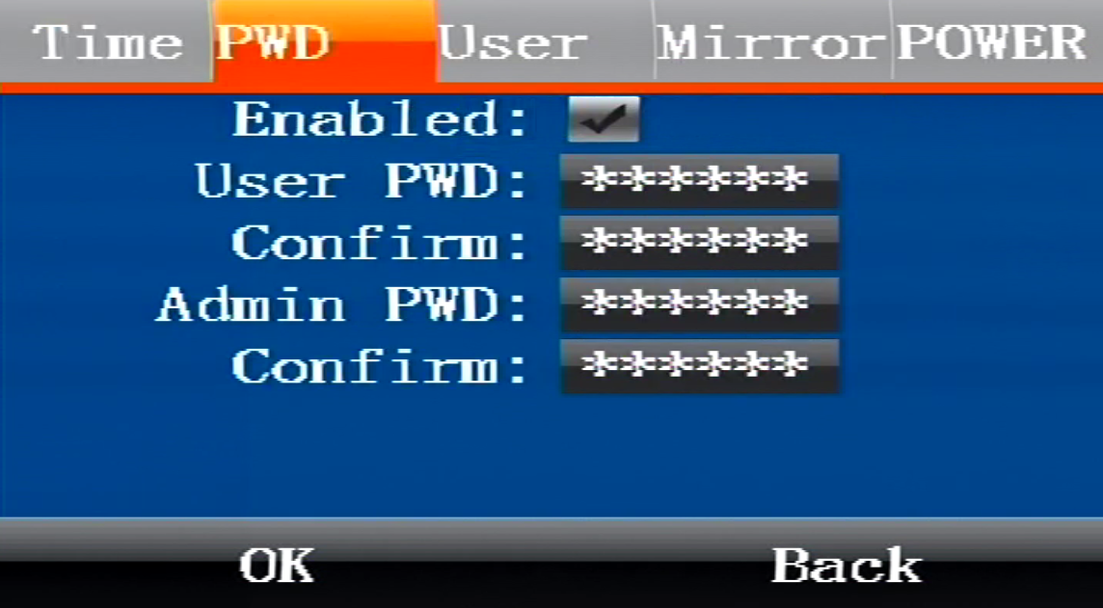

- Enabled：Press Enter keys to select or cancel, in order to access the setup menu with a password, it need input password when user access menu if select it, otherwise select no select to disable password.
- User PWD: Users can search and play video records but cannot modify parameters with this password. Press digit keys to modify the password.
- Admin PWD: Users are endowed full rights with this password, such as search, play or modify parameters. Press digit keys to modify the password.
- Confirm：It is used to confirm password, Press digit keys to modify the password.
Select “OK” and press 【ENTER】to save the settings.

- User

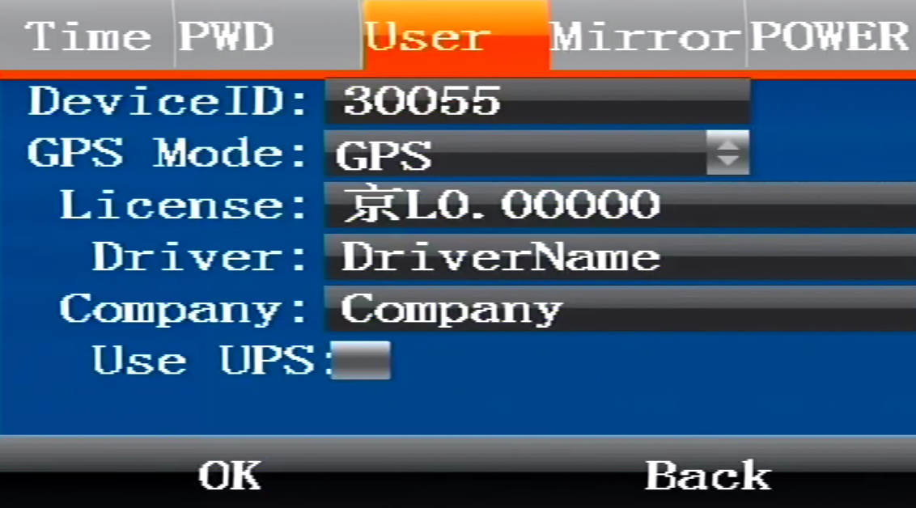

- Device ID：It is used to set mdvr device number;
- GPS Mode: Press 【ENTER】key to select GPS work mode, it have three modes: GPS, BD, BDGPS.
- License: It is used to set car license number.
- Driver: It is used to set driver name.
- Company: It is used to set the company name of mdvr.
Press 【ENTER】key to select and enter the keyboard menu, move the cursor to select letters.

- Mirror

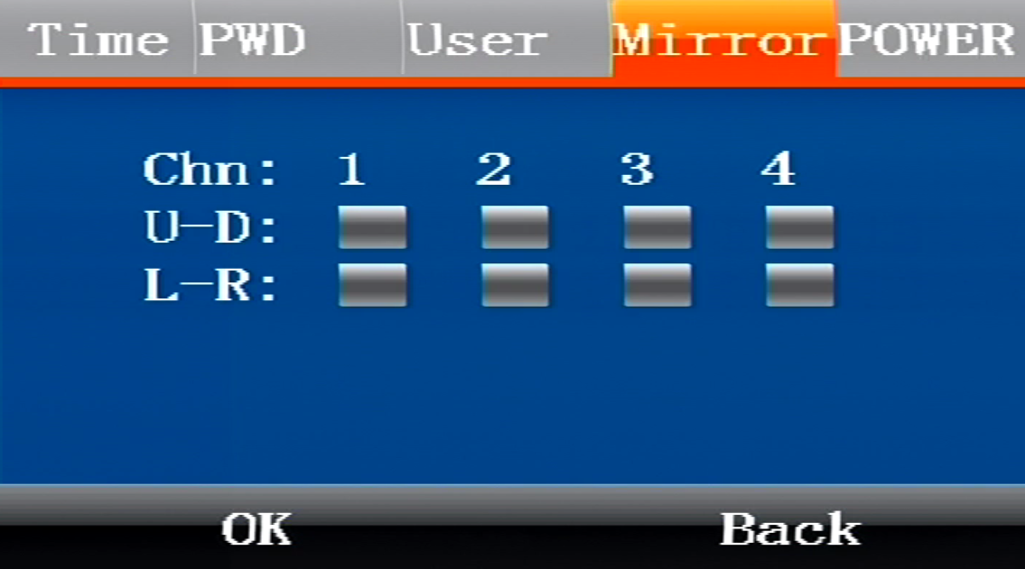

Used to set 1-4 channel video mirror mode.

- Power

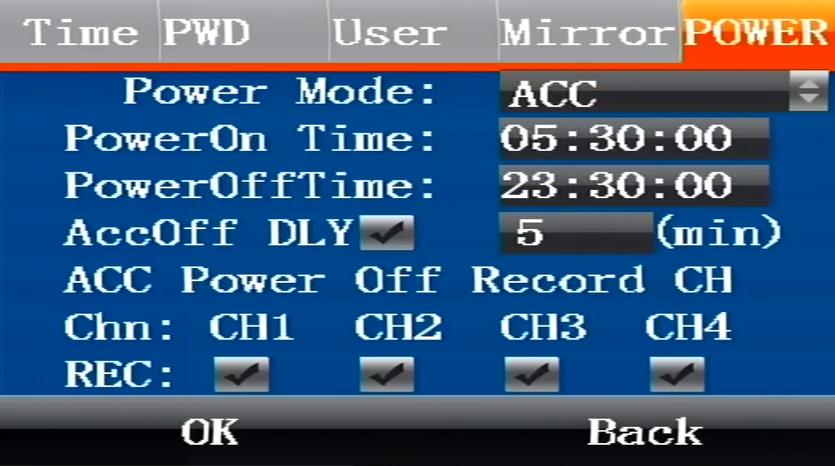

Used to set the switch mode of the device, whether to continue recording after ACC is turned off.

13.5.2 Alarm
This menu will show you how to setup the alarm parameters, include alarm, Input/output, linkage and G-sensor.

- Alarm

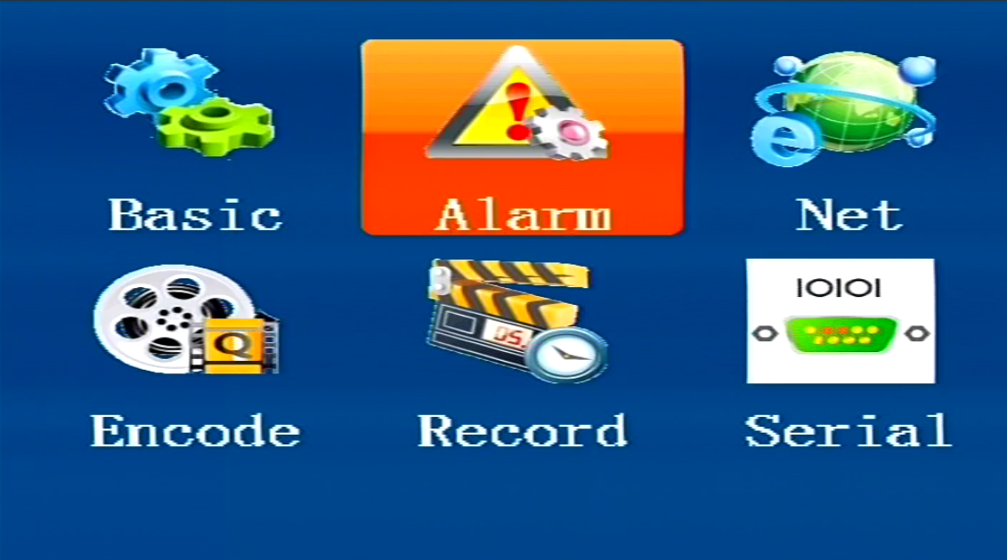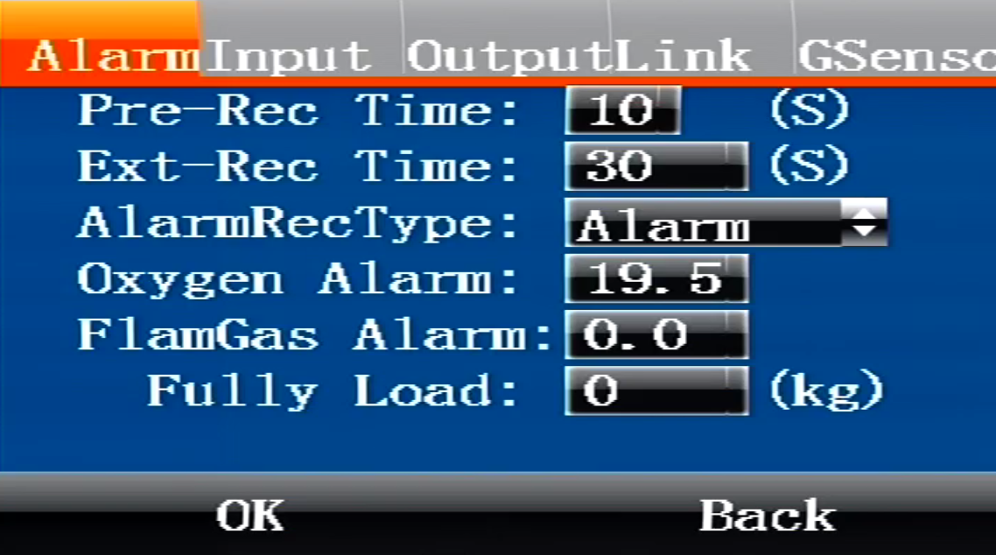

This menu configures the alarm input and alarm output linkage related parameters of the device.

- Input

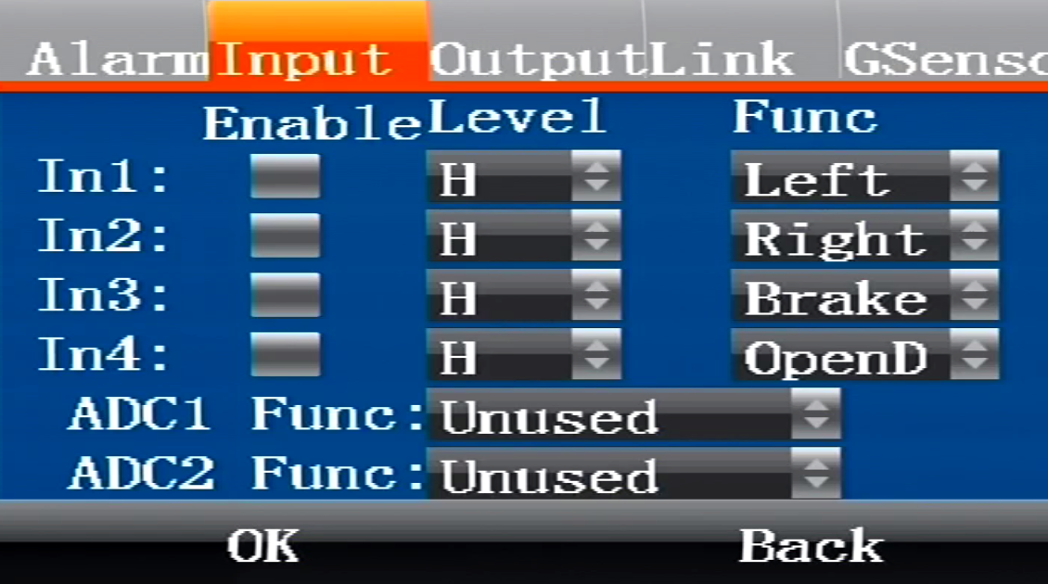

This menu is used to configure IO alarm input, and can set 4 alarm inputs.

- Output
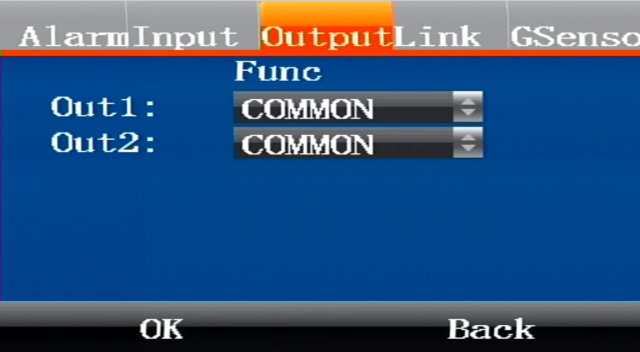

Select the level, select high level, the alarm output is high, function selection (network, oil control, etc.)

- Linkage

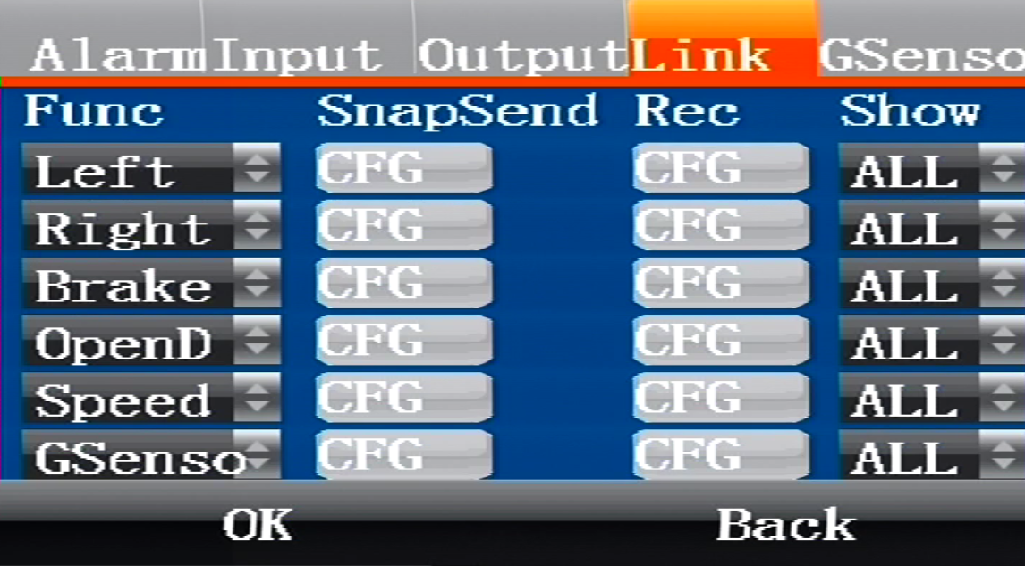

Corresponding to 4-way alarm input, overspeed, GSensor function linkage alarm

- GSensor

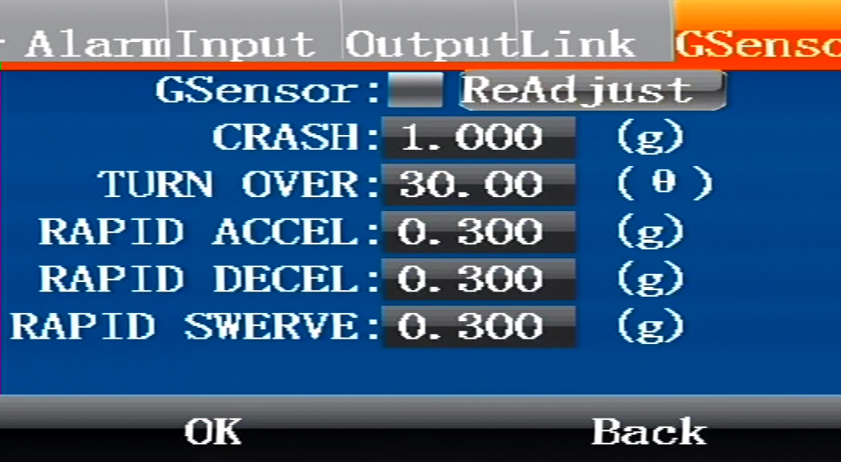

This menu is used to set the Gsensor value to be turned on and viewed. Gsensor static calibration

13.5.3 Net
This menu will show you how to setup the system network parameters, it includes: Mode, Center, 3/4G,net and WIFI.
- Mode

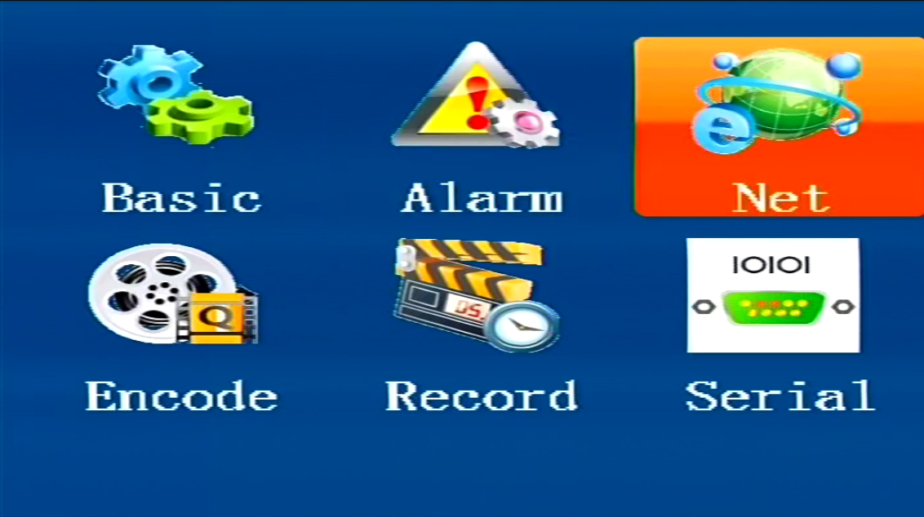
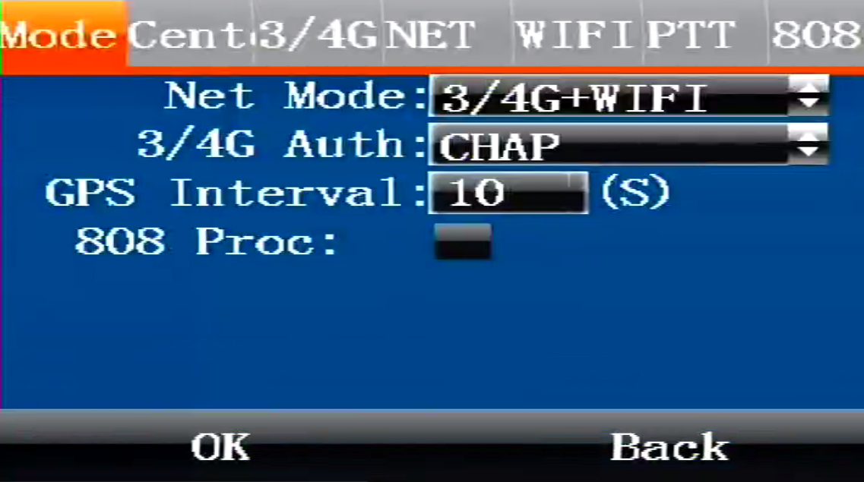

Used to set parameters such as device network mode.

- Center

- Link Mode：This item is used to set the access back-end platform through IP or domain mode.
- Server IP： This item is to set the back-end CMS server IP address.
- Domain：This item is used to set the back-end CMS server domain name.
- Port：This item is used to set the back-end CMS server port.
Select “OK” and press 【ENTER】to save the settings.
- 3/4G

- 3/4G Type：This item is used to set .
- 3/4G APN： This item is to set .
- Center NO：This item is used to set .
- User Name：This item is used to set .
- Password：This item is used to set .
Select “OK” and press 【ENTER】to save the settings.

- Net
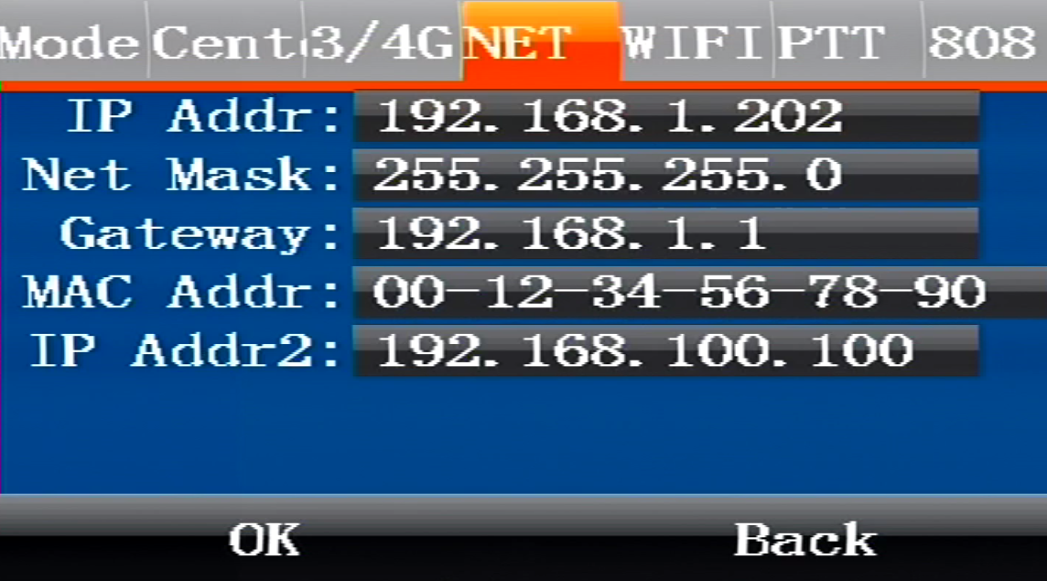
Used to set related parameters such as device IP.

- WIFI

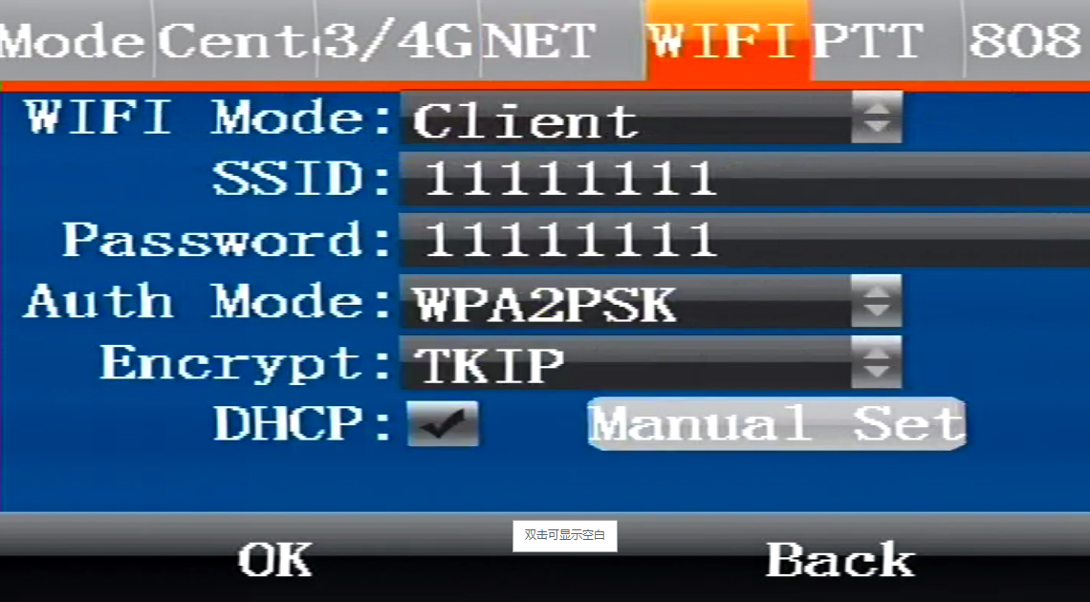

Used to set the device's WIFI mode and corresponding parameter configuration.

13.5.4 Encode
This menu will show you how to setup the video encode parameters.

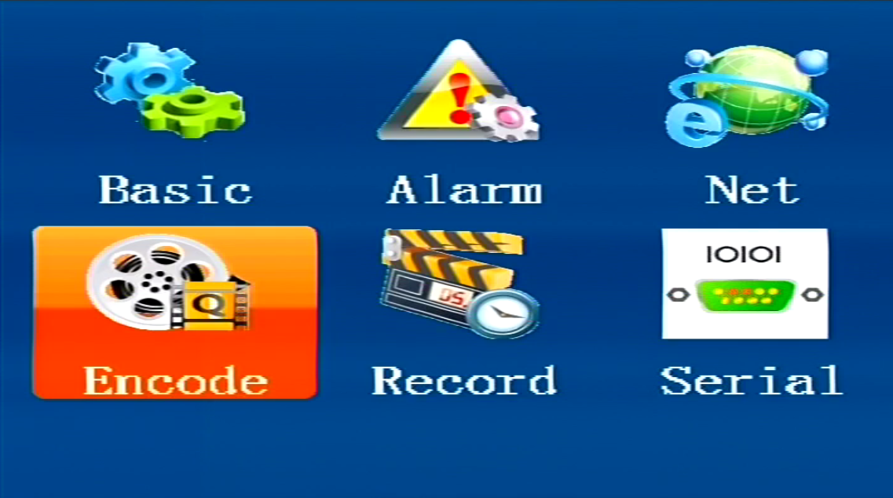

- MAIN

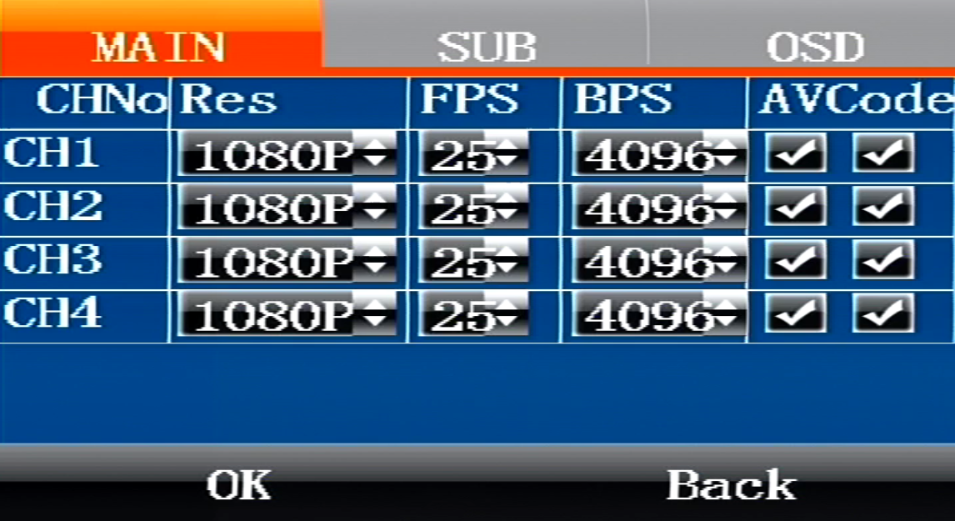

For selecting 1080P, 720P, D1 resolution type, audio on/off, image resolution 1080P is best, D1 is the worst.

- SUB

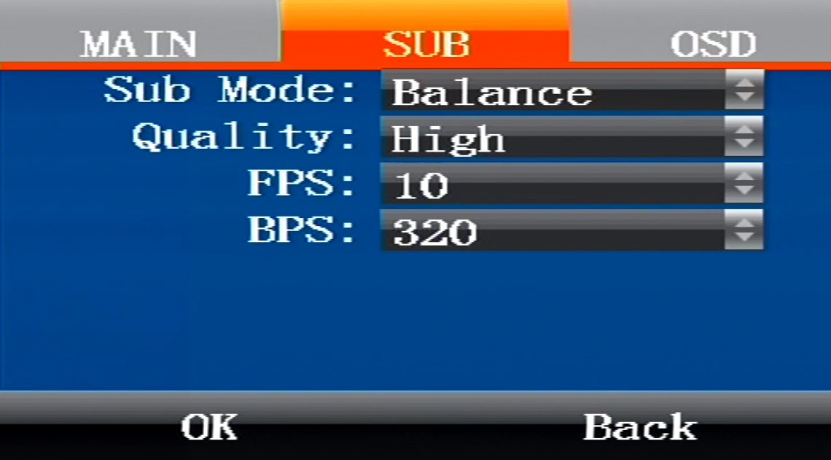

It is used to select parameters such as encoding mode definition and image quality.

- OSD
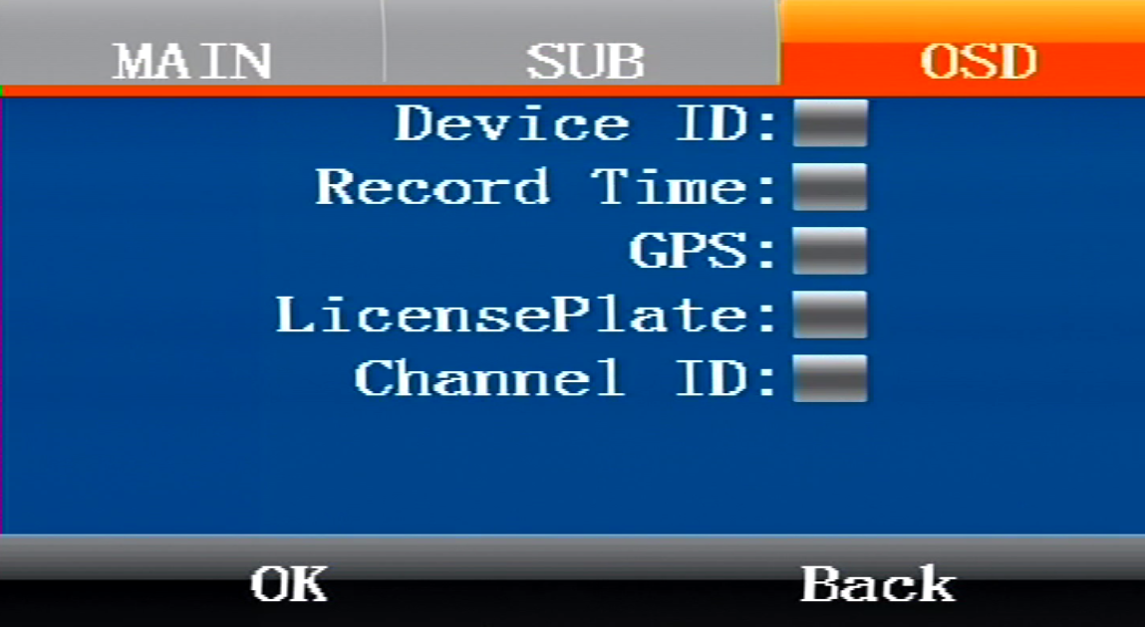

Use and superimpose license plate, equipment number and other parameters.

13.5.5 Record

- CType

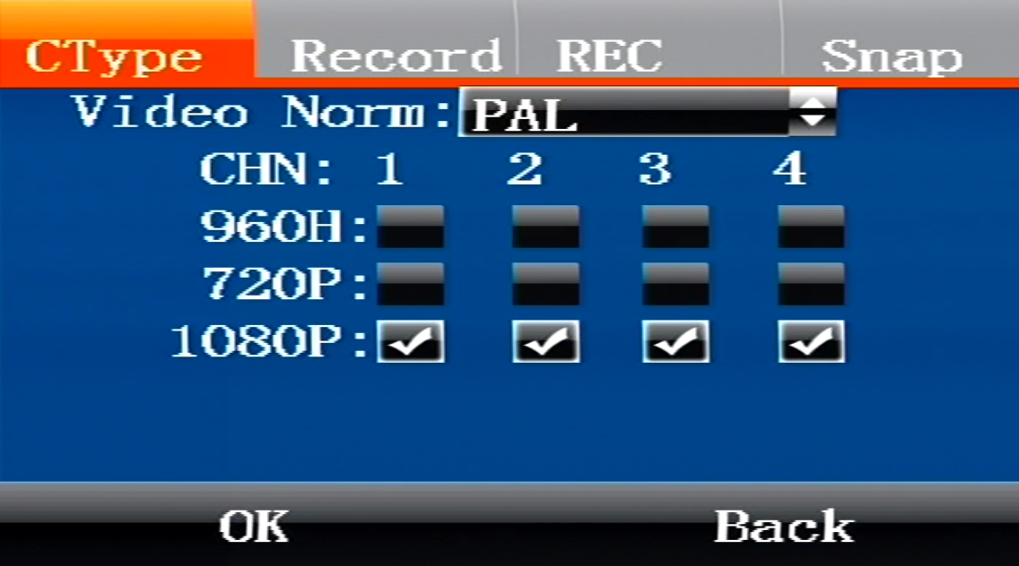

Choose to use Pal or NTSC camera.

- Record

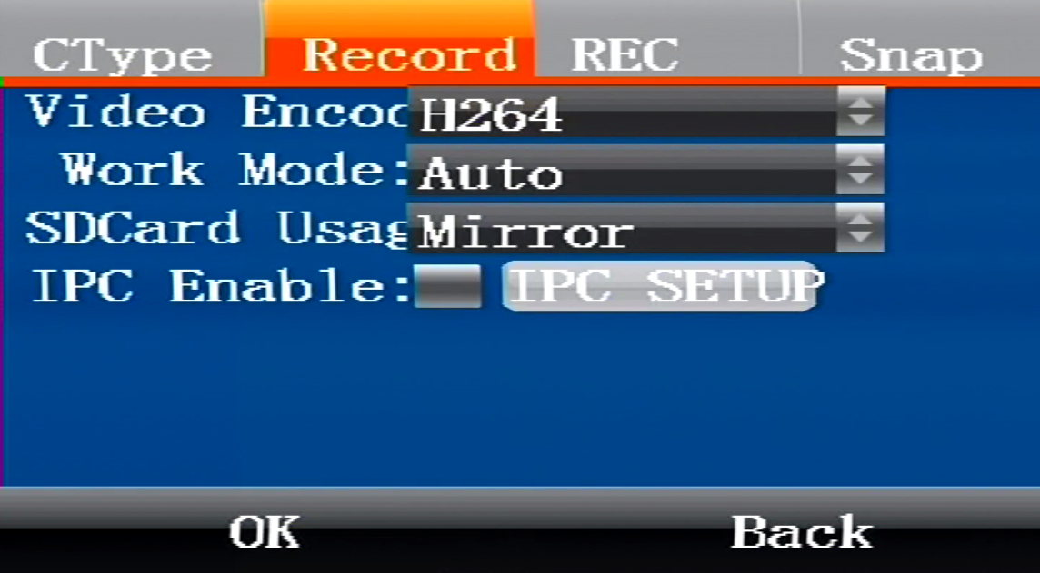

Enable IPC and IPC parameter settings, up to 4 channels of IPC.

- Snap

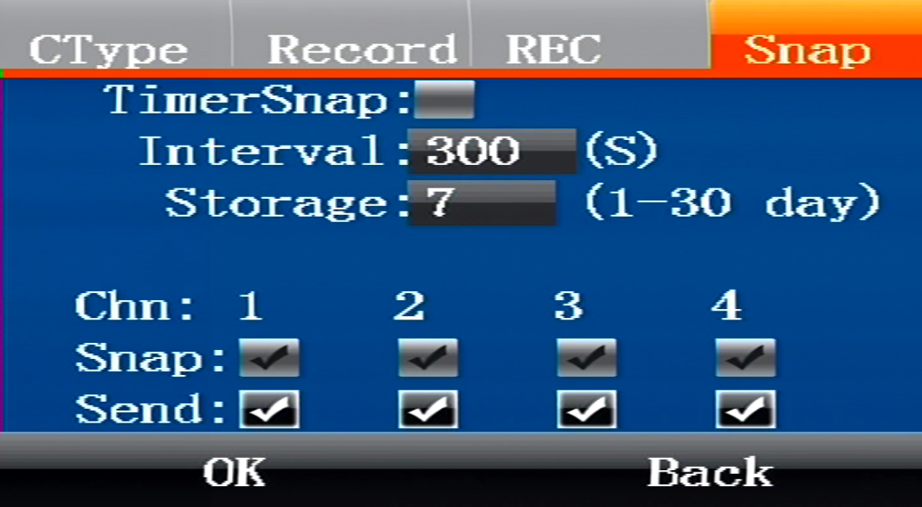

Set the captured image to automatically save the number of days, the image will be deleted automatically after the set number of days, configurable time 1-30 days, default 7 days

FAQ

Questions on device turn on

Answer:
- The power supply voltage does not reach 8-36V or the power does not reach 50W or more.
- Hard disk lock is unclosed.
- The power connection method is incorrect. Please refer to the power cable instructions.
- Maybe motherboard or power supply hardware is faulty, please contact the supplier.

14.2 Questions on 3/4G

14.2.1 Q: Failure to transfer 3/4G data?
A: This may be caused by the following causes:
- 3/4G antenna not connected;
- SIM card not connected;
- Incorrect wireless settings in the settings menu. Such as failure to enable wireless dialing, incorrect 3/4G protocol setting or incorrect access point setting;
- Incorrect settings of center server in the settings menu. Such as incorrect center IP;
- Incorrect settings of PC. Such as no port mapping of the gateway router of the PC;
- PC playback tool is disabled;

14.2.2 Q: Can 3/4G remote preview and local recording be carried out synchronously?
A: Real-time preview at the control center and local video storage can be achieved.

14.2.3 Q: How about the 3/4G transmission rate?
A: It depends on the 3/4G bandwidths of different countries, according to current tests, 4 channels of images, 15 frames per channel, can be realized with EVDO in China.

14.2.4 Q: What is the time delay for 3/4G remote preview?
A: It is about 2-20 seconds, depending mainly on the bandwidth.

14.2.5 Q: How to download video files with 3/4G?
A: Manual file downloads are possible.

14.2.6 Q: Can recording settings be realized with 3/4G remote operation?
A: Recording settings cannot be realized with 3/4G.

14.3 Questions on Wireless Module

14.3.1 Q: What settings should be taken into consideration if wireless module dialing is selected?
A: First select the embedded wireless module, and then select corresponding wireless module type: WCDMA, EVDO, TD, as for data access point, CMNET should be selected for accessing general public network and settings of the center shall be considered for accessing VPN, depending on the formation of the data access point.

14.3.2 Q: What should be done first in case of wireless module problems?
A: Enter the information display page or system information page of the direct access menu to check the dialing status, existence of SIM card, existence of wireless module and contact status of the antenna.

14.4 Questions on Recording

14.4.1 Q: The device fails to record video?
A: This may be caused by the following causes:
- Incorrect setting of recording mode, for instance, the alarm recording mode is selected while there’s no alarm; the timed recording mode is selected while the current time does not fall into the preset period;
- Check the disk space. If the disk space is lower than 500M and the auto writing function is disabled, the recording will be stopped;
- The ERR indicator on the front panel is on. You may check the system information whether the disk space is shown to be 0; check whether the disk is inserted and whether it is formatted;
- The recording functions of the 4 channels are disabled in the menu settings;

14.4.2 Q: No sound in the video?
A: This may be caused by the following causes:
- Incorrect audio input connection. If the user connects line AIN1 and AIN2, the user needs to turn on the audio switch and select LINE IN input in the Recording Settings menu; if MICIN is connected, the user needs to turn on the audio switch and select MIC input in the Recording Settings menu;
- Audio output cable is not connected or incorrectly connected;

14.5 Questions on Alarm

14.5.1 Q: Invalid alarm triggering?
A: This may be caused by the following causes:
- Incorrect settings on the Alarm Settings menu; such as failure to enable alarm for designated alarm input and incorrect output level configuration;
- Incorrect connection of alarm input or failure to connection alarm input;
- Incorrect signal level of the triggering source of alarm;

14.5.2 Q: Invalid alarm output?
A: This may be caused by the following causes:
- Incorrect connection by the user;
- Incorrect menu settings, such as failure to enable alarm output or incorrect output level configuration;

14.6 Others

14.6.1 Q: The power indicator is not on when the device is powered on?
A: This may be caused by the following causes:
  - The voltage falls beyond the range between 8V and 36V;
  - The fuse on the power input wire is burnt out;
  - The ignition signal is not connected;

14.6.2 Q: The ERR indicator is on?
A: This may be caused by the following causes:
- Neither the SD card nor the hard drive is inserted, or the SD card and hard drive are inserted while the system partitioning is abnormal, causing failure of the device in recognizing; 2) Disk reading/writing error;
- Abnormal operation of the SCM;

14.6.3 Q: The SD card indicator is not on or flashing?
A: There are three states of the SD card indicator: on, out and flashing, respectively indicating the following:
Out: The SD card not inserted or failure of the device to recognize the SD card;
On: The SD card exists but not the storage for the current recording
Flashing: The SD card exists and is the storage for the current recording;

14.6.4 Q: The hard drive indicator is not on or flashing?
A: There are three states of the hard drive indicator: on, out and flashing, respectively indicating the following:
Out: The hard drive not inserted or failure of the device to recognize the hard drive;
On: The hard drive exists but not the hard drive for the current recording;
Flashing: The hard drive exists and is the disk of the current recording;

14.6.5 Q: Both the SD card indicator and the hard drive indicator are on while not flashing?
A: This may be caused by the following causes:
- The device considers no current recording tasks according to the menu settings by the user;
- Both the SD card and the hard drive are full while the auto overwriting function is disabled in the menu;

14.6.6 Q: Blank screen of some channels?
A: This may be caused by the following causes:
- This channel is not connected to the video;
- The camera connected to this channel is damaged or abnormal;
- If the camera is powered through the device, it may be possibly that the voltage of the device cannot ensure normal operation of the camera;
- Poor contact or damage of the cable connecting this channel;

14.6.7 Q: No GPS signal?
A: This may be caused by the following causes:
- GPS antenna is not connected;
- GPS antenna is placed indoors;
- GPS module is damaged;
- The software is for 7001 and does not support this function;

14.6.8 Q: Abnormal G-Sensor data?
A: This may be caused by the following causes:
- G-Sensor not calibrated. G-Sensor should be calibrated in the settings menu;
- The software is for 7001 and does not support this function;
- G-Sensor is damaged;

14.6.9 Q: Video files cannot be played back on the PC?
A: This may be caused by the following causes:
- Video file directory or video files are not selected. Please select the video file directory before playback;
- Local video files are damaged, causing failure in reading;

14.6.10 Q: The remote controller does not work?
A: This may be caused by the following causes:
- No battery in the remote controller;
- Remote controller damaged;
- Device failure;

14.6.11 Q: The map is not displayed during the playback?
A: This may be caused by the following causes:
- The network cable for the PC for playback is not connected;
- The PC is unavailable for accessing the network although the network cable is connected;

14.6.12 Q: How does the overwriting function of video files work when recording video on the SD card and the hard drive?
A: The SD card and the hard drive will respectively record video circularly, and when the SD card and the hard drive are full, the oldest video files in the card or disk will be deleted.

14.6.13 Q: Are remote on/off operations supported?
A: Not supported at present, but possibly.

14.6.14 Q: Are there suggestions on the priority of SD card? Is SDHC card supported?
A: Kingston SD card is mainly support at present, and SDHC card is also supported.

